E-W Indicator Framework BI Reports Setup Guide

**October 2024**

This setup guide is the reference document for implementing the [Education-to-Workforce (E-W) Indicator Framework](https://www.educationtoworkforce.org/) Power BI reports. These reports reference the 20 [essential questions](https://www.educationtoworkforce.org/essential-questions) for E-W data systems to demonstrate how students are progressing from early education through career. The reports are stored on the CEDS Collaborative Exchange in the open-source Community where anyone using the CEDS Data Warehouse can access and use their own systems. This setup guide includes:

* Report prerequisites.
* Instructions for preparing the CEDS Data Warehouse for the report.
* Instructions for downloading and connecting the report to the CEDS Data Warehouse.
* Best practices for distributing the report.
* Information about refreshing data within the report.

# Assistance

If you require assistance with installing or using the E-W Indicator Framework reports, please contact [ewframework@aemcorp.com](mailto:ewframework@aemcorp.com).

# Reports Prerequisites

* Have Generate or the CEDS Data Warehouse installed.
* Have the latest version of Power BI Desktop installed.
* VPN Access, if required.

# About the Reports

Within the 20 essential questions, the E-W Indicator Framework has 99 [indicators](https://www.educationtoworkforce.org/indicators) with suggested metrics provided for each. The metrics were developed as [CEDS Connections](https://ceds.ed.gov/connectFind.aspx?abbr=1) (select Education-to-Workforce Indicator Framework in the Category drop down) which documents the elements and analysis criteria required to track the metric using your own education data systems. To assist users in reporting on the metrics, CEDS Connections are being used to develop public facing Power BI reports.

## **Suppression**

To protect individual privacy, all visuals in the reports have cell sizes under 10 suppressed. There are no drilldown features, as all personally identifiable data (PII) have been removed.

**Essential Questions**

Below is a table indicating the reports currently available and information specific to each report.

| **Essential Question** | **Report Name** | **CEDS Connection** | **Github link** | **Report Release Date** | **Years of Data**  **Used in Report** |
| --- | --- | --- | --- | --- | --- |
| 14: Are students graduating from high school on time and successfully transitioning into further education, training, or employment? | [Postsecondary Enrollment After High School](https://github.com/CEDS-Collaborative-Exchange/Education-to-Workforce-Indicator-Framework/tree/main/Essential%20Question%2014) | https://ceds.ed.gov/connectReport.aspx?uid=30903 | [Link](https://github.com/CEDS-Collaborative-Exchange/Education-to-Workforce-Indicator-Framework/tree/main/Indicators/Postsecondary%20enrollment%20directly%20after%20high%20school%20graduation) | October 2024 | 1 |
| 14: Are students graduating from high school on time and successfully transitioning into further education, training, or employment? | High School Graduation |  |  | *Expected Spring 2025* | 1 |

# Preparing CEDS Data Warehouse

E-W Indicator Framework reports typically connect one or more SQL Views in the CEDS Data Warehouse to gather report data.

SQL Views pulls data from fact and dimension tables within the CEDS Data Warehouse for reporting purposes.

The required views are:

* Report: EW Framework Postsecondary Enrollment
  1. View: RDS ReportEwFrameworkIndicators
  2. Description: High school graduates enrolled in a postsecondary institution by October 31 following their high school graduation.

**Instructions**

To add the required SQL Views:

1. Save the script for the report found in the report’s individual folder on the Education-to-Workforce-Indicator-Framework Github page. See table above for link to the appropriate folder.
2. Open each view in your SQL Management Studio (or similar).
3. Open and execute the view into your copy of the CEDS Data Warehouse. This will add the required views.

## **Notes**

1. If you change the SQL View name, field names, or the values returned, you will need to update the BI tool to reflect the changes.
2. The logic in these SQL Views may need to be changed if the CEDS reporting standards change.

# Connecting the report to the source

The .pbix file with a copy of the report is available in the CEDS Collaborative Exchange’s github repository: <https://github.com/CEDS-Collaborative-Exchange/Education-to-Workforce-Indicator-Framework.>

The downloaded report contains cached test data. This test data was created for this report's prototype and does not represent any actual state data. To use the report with your state’s data, **the report needs to be connected to a state’s CEDS Data Warehouse instance.**

## **Instructions**

1. Connect to the VPN if required by your network administrators.
2. After downloading the .pbix file, open it in your Power BI Desktop instance. As a reminder, the data in the report after the initial download will be cached test data.
3. To use your data in the report, connect it to the CEDS Data Warehouse.
   1. Click ‘Data source settings’ in the ‘Home’ tab.

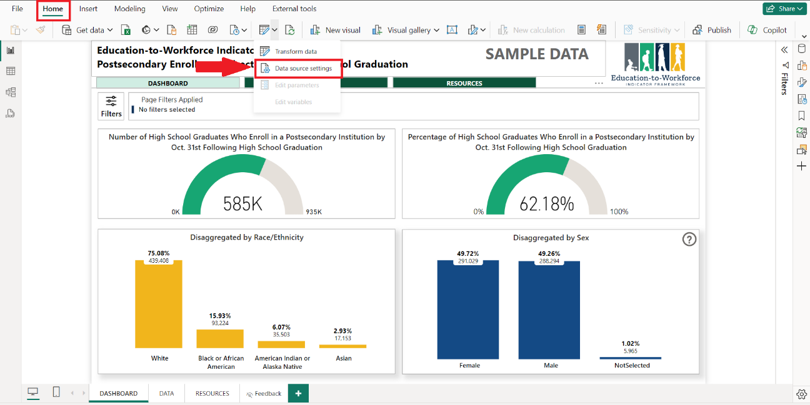

* 1. In the data source settings panel, select the default data source then click ‘Change Source...’.

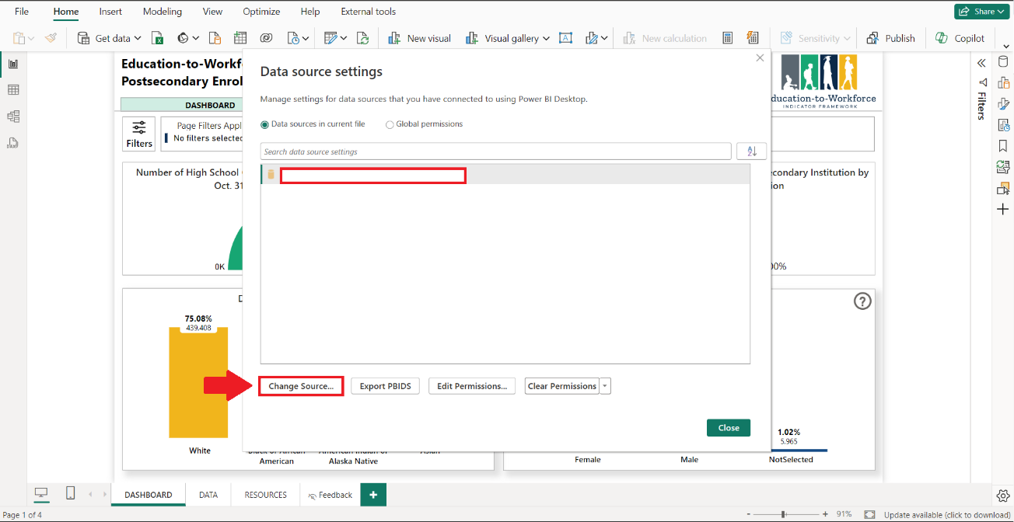

* 1. Replace the Server and Database fields with the IP address and database name related to your CEDS Data Warehouse. Click ‘OK’.

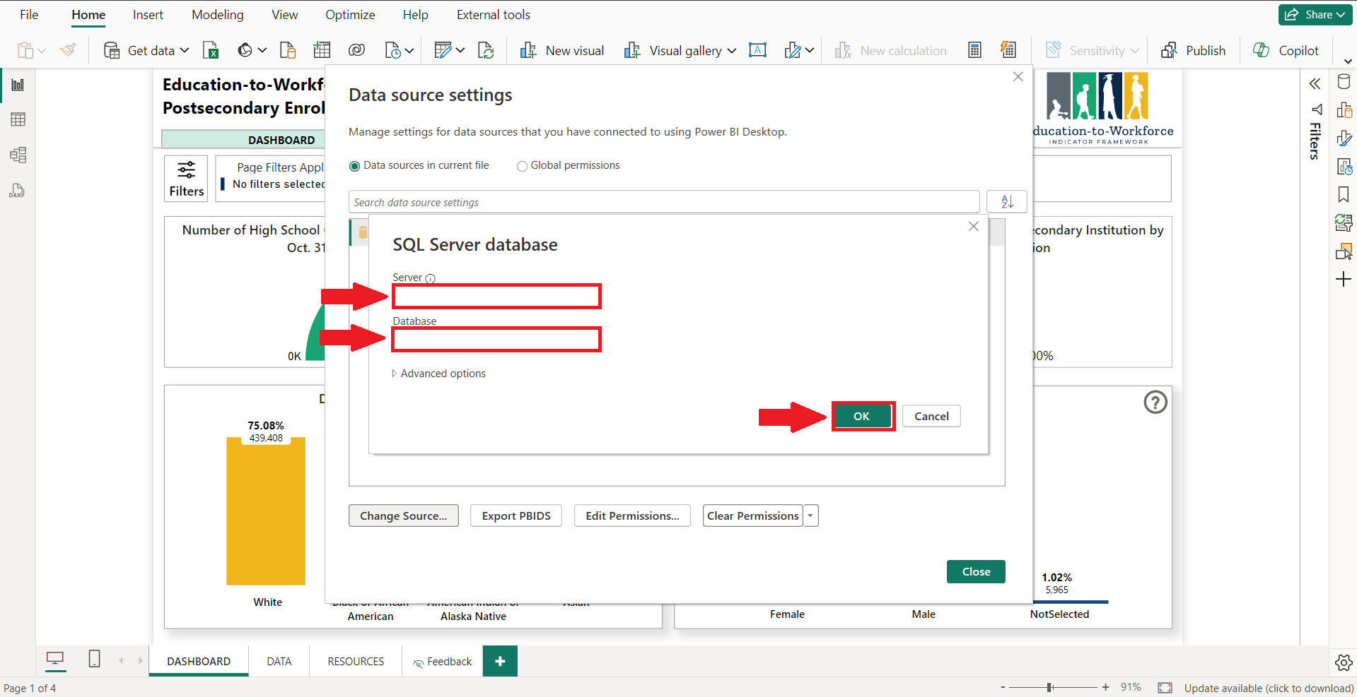

Your dataset will now refresh and cache within your report. This may take a few minutes, depending on the size of your dataset. After connecting the dataset, the front end of the report can be reviewed and used.

# Distribution

**Ensure this report is shared only with authorized individuals.** Refer to your agency’s policies and procedures before sharing this report. While the .pbix can be sent to individuals with Power BI Desktop, it is recommended this report is distributed with internal agency staff through an online Power BI Workspace. Doing this ensures access is limited to appropriate individuals and the report cannot be edited, and provides multiple sharing options, such as embedding into a Teams Channel.

## **Instructions**

To share through an online workspace

1. Navigate to office.com then sign in with your credentials.
2. Click the menu icon then select Power BI.

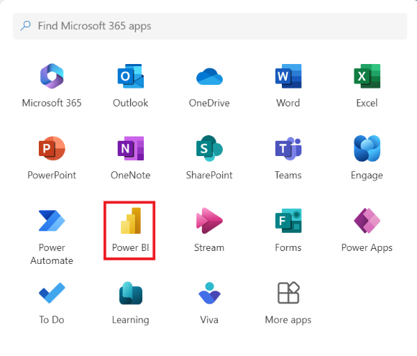

1. In the left menu bar click ‘Workspaces’ then ‘New Workspace.’
2. In the panel, fill in the required information.

1. Once the workspace is created, upload the .pbix file to the workspace.

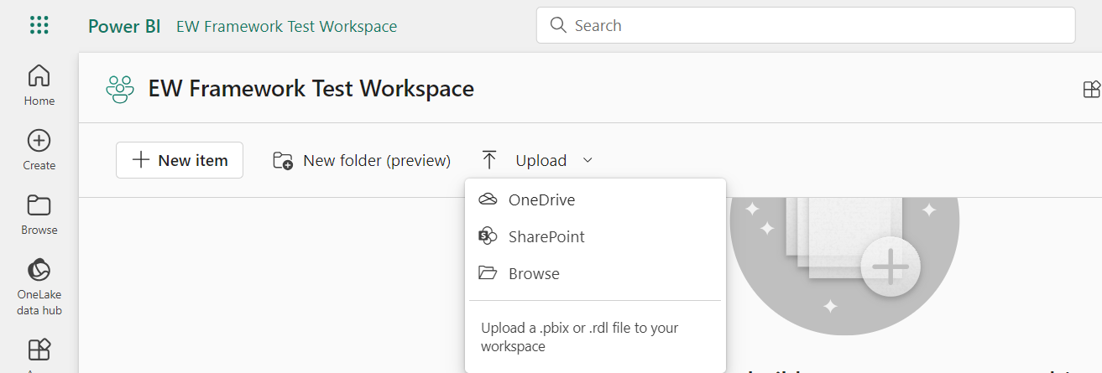

1. After the report is uploaded in the workspace, the dashboard will be available to use and share by clicking on the .pbix file.

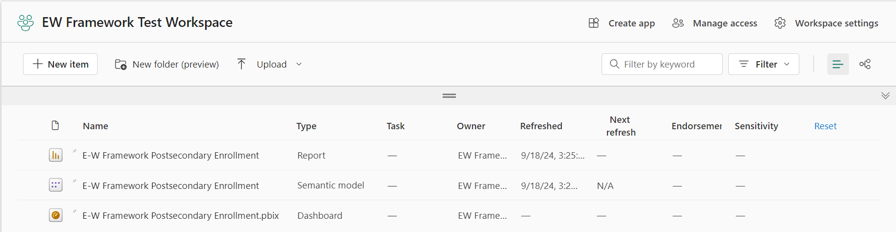

1. Once you have navigated to the report, manage access permissions for appropriate individuals in your organization, by clicking share.

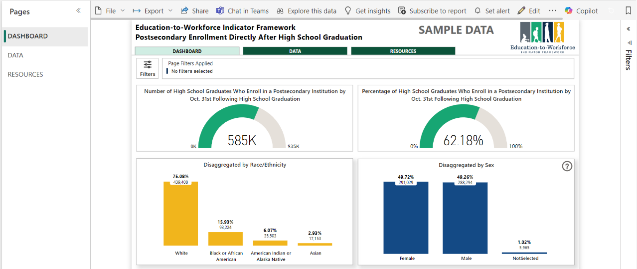

1. Type in the name of the person you want to provide access. Then click the method you would like to send through.

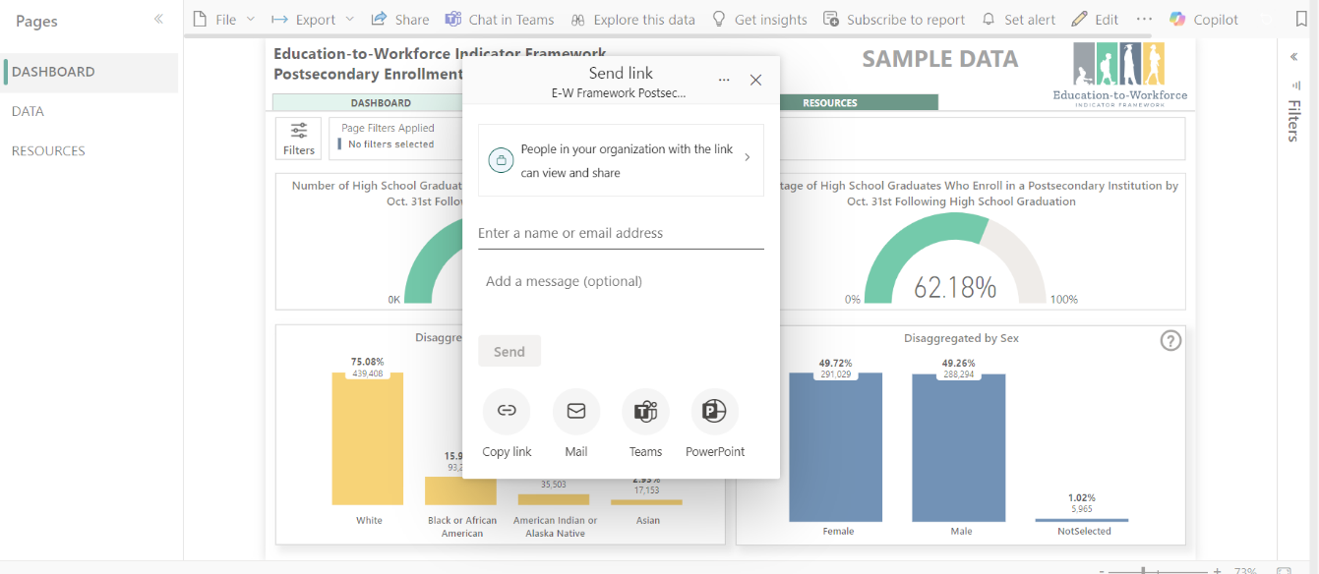

# Refreshing Data

Administrators of the report can refresh the data in different ways.

## **Instructions**

* If using the report as a desktop .pbix file:
  1. Click the refresh button to view updated data.
  2. After refreshing data, click publish to allow authorized users to view the data.
* If using the report in the workspace:
  1. Go to the semantic model and click the refresh button.

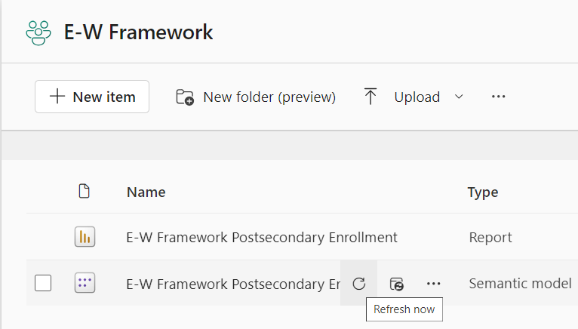

* To setup a scheduled refresh:
  1. Click the ellipses next to the data set.
  2. Click ‘Settings.’
  3. Navigate to the Refresh dropdown and set your refresh frequency.

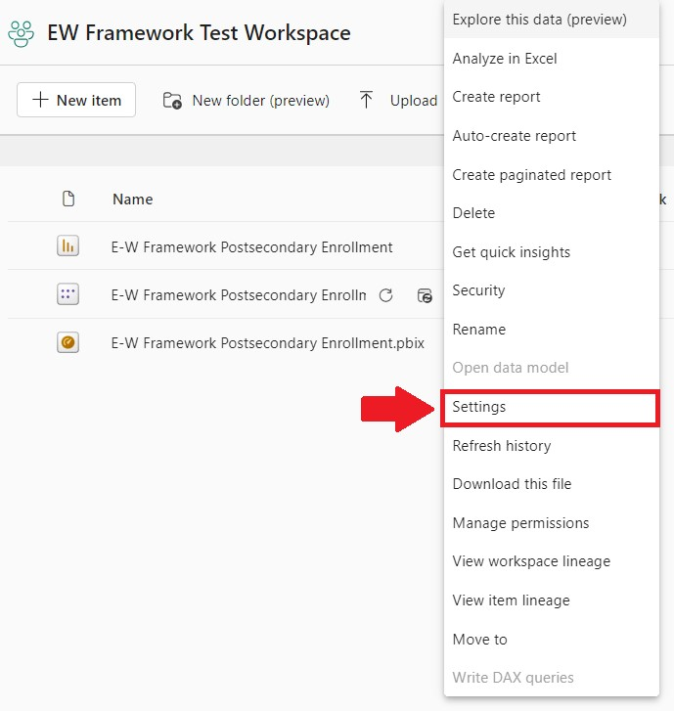

# Assistance

If you require assistance with installing or using the E-W Indicator Framework reports, please contact [ewframework@aemcorp.com](mailto:ewframework@aemcorp.com).